Lloyds Bank Group

### Customer Churn Report

**Summary of Inclusion:**

* **Customer_Demographics**: Understand the demographic factors related to churn.
* **Transaction_History**: Analyze spending behavior and identify changes leading to churn.
* **Customer_Service**: Address and improve service-related issues contributing to churn.
* **Online_Activity**: Monitor engagement levels to identify at-risk customers.
* **Churn_Status**: Serve as the target variable for predictive analysis and model validation

The following is a visual of the revenue fluctuations over time. We see a pattern with a drop in revenue every second month with a spike in revenue for the same. Therefore, it is premature to attribute the decrease in revenue for the last month to a result of customer churn.

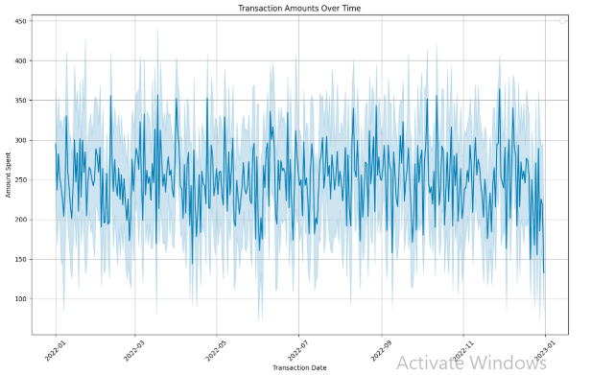

However, looking at customer inquiries. We see a worrying percentage of unresolved inquiries.

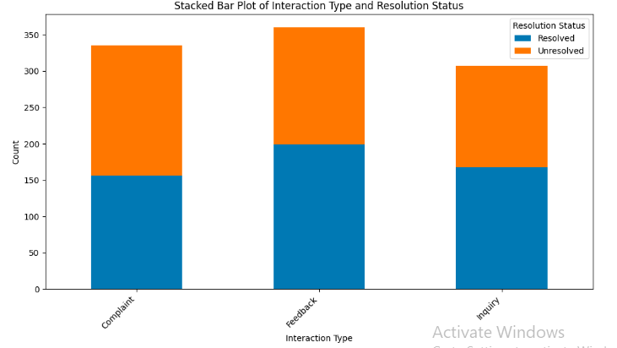

The total revenue per month are looking stable.

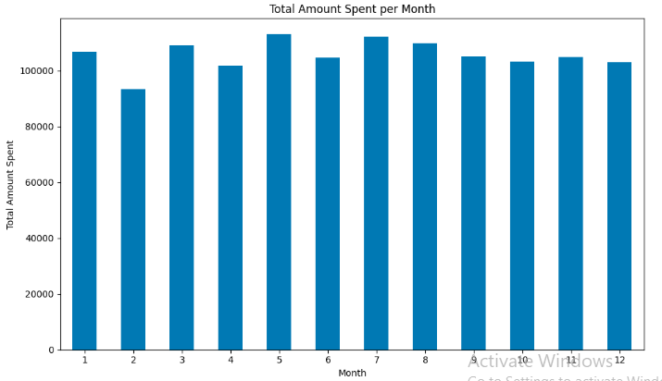

We percentage of unresolved inquiries are the most likely contributor to customer churn and needs more attention.

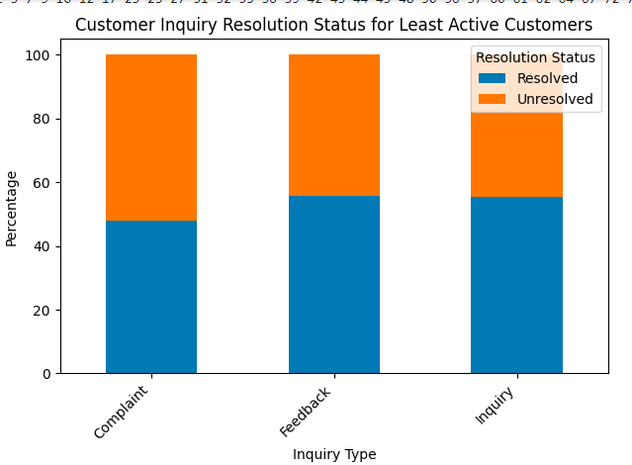

From the inquiries of customer who made the least purchases within the last three months, the data are as follow:

